AgroExpo Exhibitor Social Post
Change out the image and add your booth number on the attached PDF to create a custom social post to promote your booth at the 2026 AgroExpo.
- Open the PDF file “Promo_AE-26_Social.pdf” in a PDF editor. This example is using Adobe Acrobat Pro, your editor may look different.
- Select “Edit” to change the image and booth number.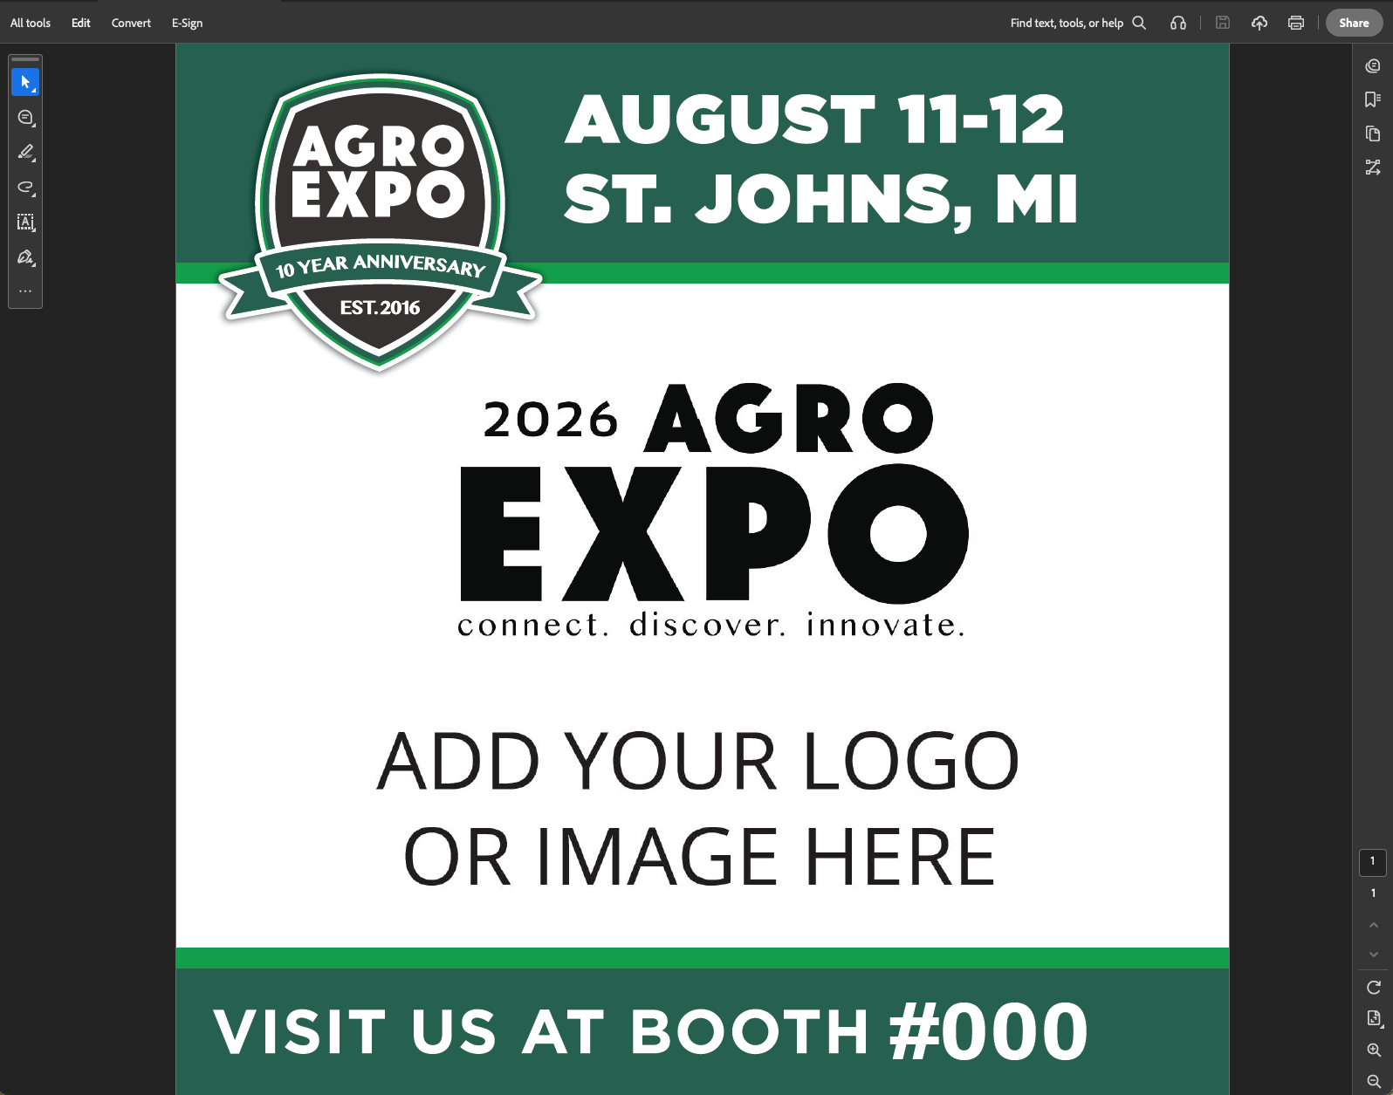
- Click the center image with “ADD YOUR LOGO OR IMAGE HERE” and a panel will open with several options.
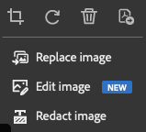
- Select “Replace Image” and navigate to your logo or image you’d like to use.
You can adjust the size of your image to fill the space as needed.
- Click the box that includes “#000” text and type in your booth number. (Ex: E916)

  - If the font doesn’t appear to be the same, check that it is Arial Bold, size 80.
- Once ready, exit from the Edit pane (ESC) and Save (CTRL + S) the file.

